Homework4

Tyler Poelking

2/13/2018

Question 1)

1. A non-informative prior would be if θ ~ Uniform(-1, 1). This gives θ an equal chance to be anywhere between (-1, 1). I chose these parameter values because the difference in shots made frequency cannot be less than -1 nor greater than 1.
2. A subjective prior based on my knowledge of free throw shooting would be θ ~ Normal(mean = 0.2, sd = 0.3). I chose 0.2 for the mean because it is likely that daily 50 practice shots over a month increases their shooting percentage but not by a drastic amount. I chose 0.2 because the percent improvement will vary a decent amount given student's prior skillset and their natural athletic abilities. (0.2-2(0.3), 0.2+2(0.3)) = (-0.4, 0.5).

Question 2)

1. Plot the prior density function for θ in R.

betaplot <- function(a,b){  
 theta = seq(0,1,0.005)  
 p_theta = dbeta(theta, a, b)  
 p <- qplot(theta, p_theta, geom='line')  
 p <- p + theme_bw()  
 p <- p + ylab(expression(paste('p(',theta,')', sep = '')))  
 p <- p + xlab(expression(theta))  
 return(p)}  
  
sprintf("Beta Distribution with a = %s and b = %s", 4, 4)

## [1] "Beta Distribution with a = 4 and b = 4"

betaplot(4,4)

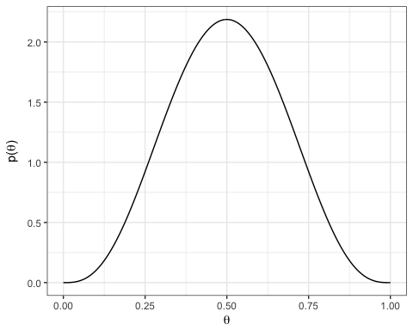

1. Flip the coin one time and find the posterior distribution for θθ conditional on the outcome of the flip. Plot the posterior density function in R.

In this case a head was received.

a = 4  
b = 4  
# calculate posterior a  
a2 = a + 1   
   
# calculate posterior b  
b2 = b + 1 -1  
  
betaplot(a2,b2)

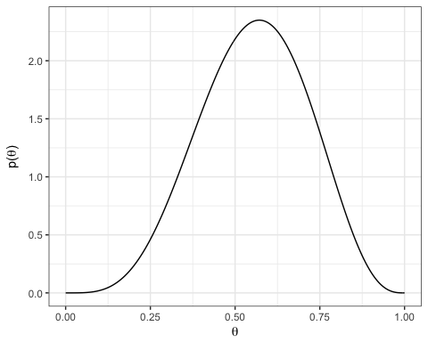

1. Now assume that the prior distribution for θ is the posterior distribution from part b. Flip the coin again. Find the the new posterior of θ and plot the posterior density function.

In this case a head was received again.

# calculate posterior a  
a3 = a2 + 1   
   
# calculate posterior b  
b3 = b2 + 1 -1  
  
betaplot(a3,b3)

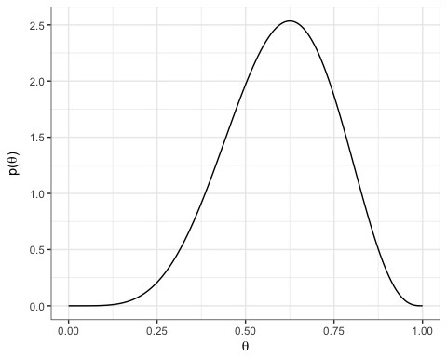

1. Assuming the original Beta(4,4) prior distribution for θθ, find the posterior distribution of θ conditional on the outcome of both coin flips. Compare this posterior distribution to the one you obtained in part c.

# calculate posterior a  
a4 = a + 2   
   
# calculate posterior b  
b4 = b + 2 -2  
  
betaplot(a4,b4)



The two distributions are exactly the same, with a = 6 and b = 4. In part b we added 1 to 'a' and in part c we added 1 again. In part d we added 1 twice. In part b and c we added 1 and subtracted 1 from 'b'. In part d we added 2 and subtracted 2.